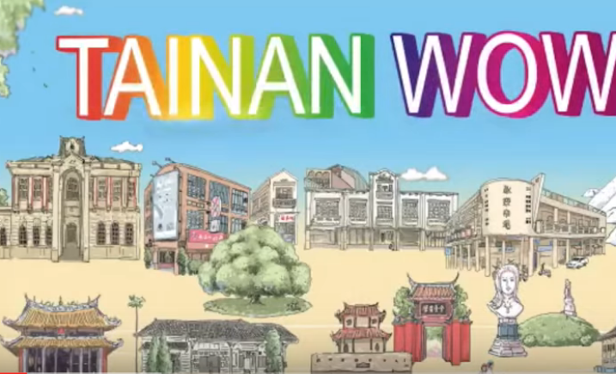
Exercise: Think of 11 questions to ask the foreigners in Tainan.
Exercise: Think of the MIT Product (local specialty) for advertising.

Q1: How long have the interviewee (Rich/ Eemy) stayed in Tainan?
Q2: What questions are the questions given for asking foreigners about their stay/visit in Taiwan?
Q3: Talk about at least one significant even in each video?
Q4: In their eyes, what does the Tainan city look like?

TainanWow第四集 外國人Rich John Matheson https://www.youtube.com/watch?v=QS4UP5XIE2Q
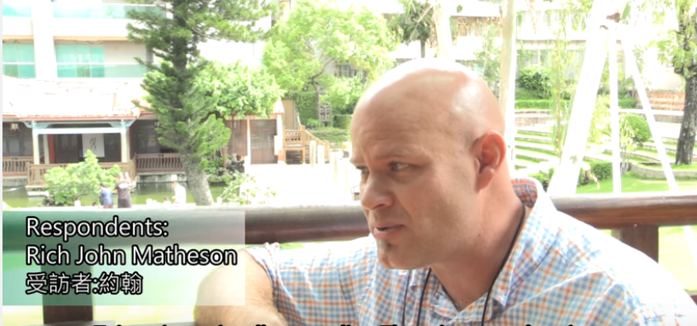

Taina wow第九集-外國人在台南吉雷米Eemy Gils https://www.youtube.com/watch?v=6P8yPEL6rYg
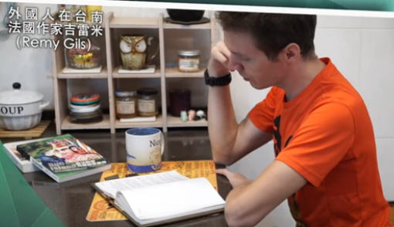

Yanshui Egg Noodles
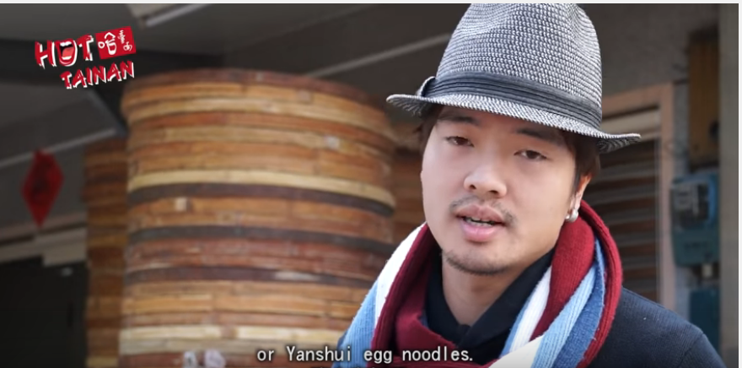  The ingredients of egg noodle? | 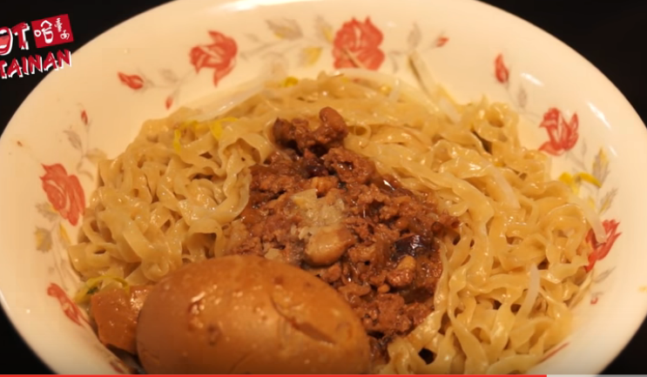  How to cook it?

Rich John Matheson

Eemy Gils came from France to Taiwan with MEP as an volunteer.
He loves languages and writes the books about how to learn the tribe languages
Of Bunong and Amei.
-- To preserve the extinguishing languages.
--He loves Tainan where it looks like Paris, owning streets and temples.
Tainan is the paradise of dessserts He likes chocalae, and Tofu pudding (An-ping)

