1.Temples
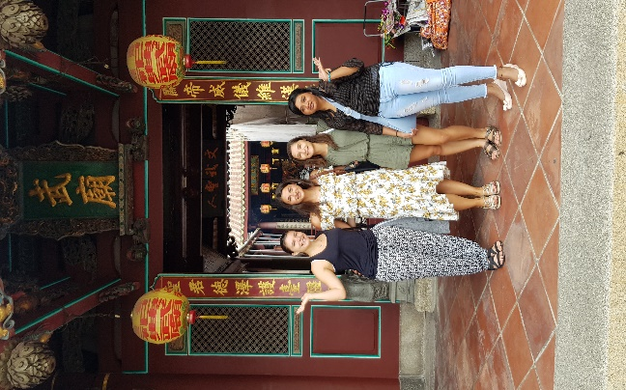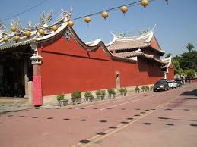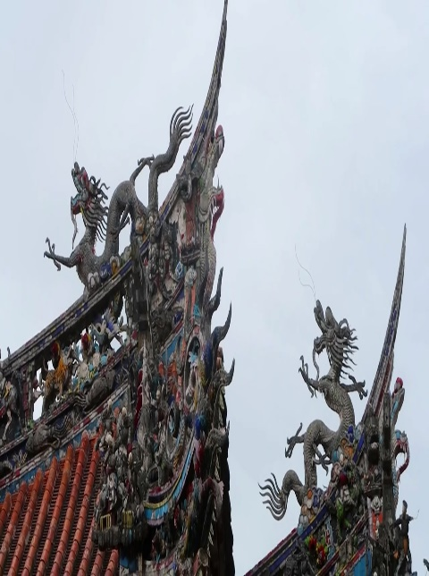
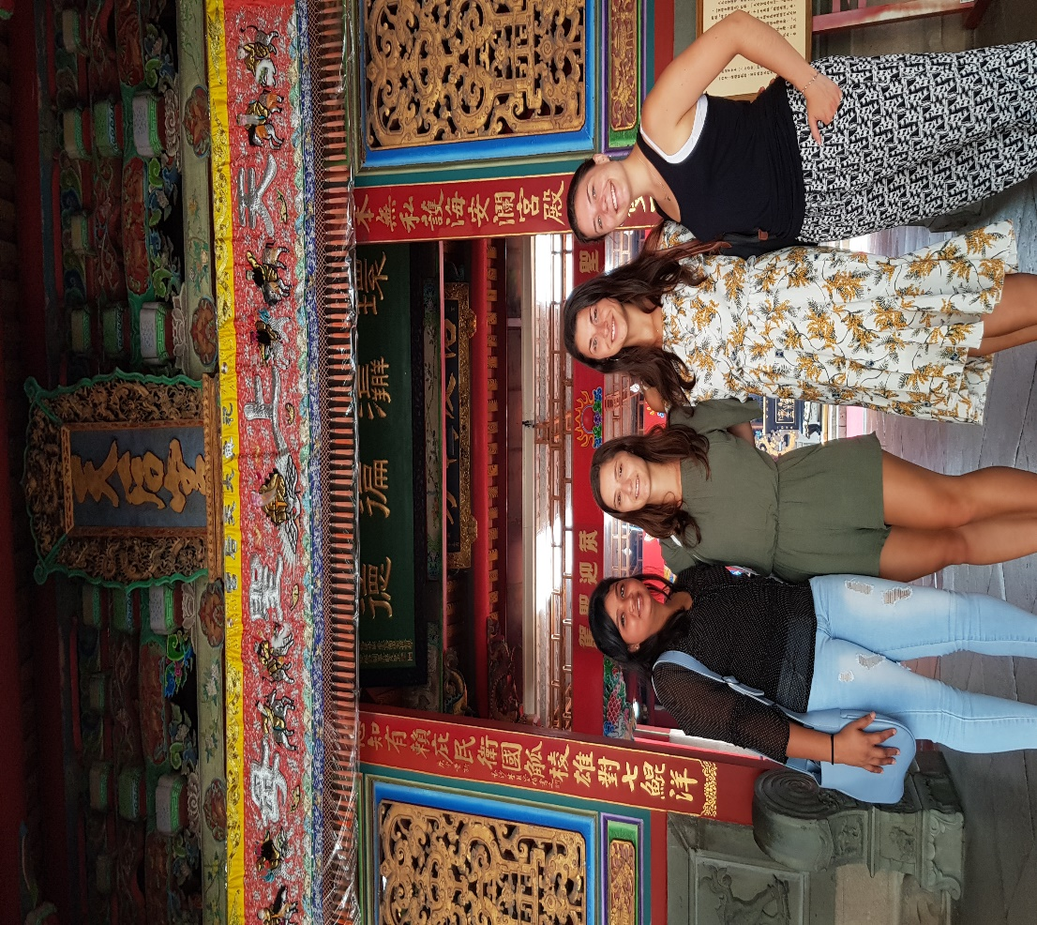

Wu Temple.
a)The temple is a grade-one national monument(一級古蹟). This temple is dedicated to (供奉) Guan Gong, a general turned into a deity, and is the only temple in Taiwan with sacrificial rites worshiping Guan gong.
b) Temples in Taiwan follow the basic principles of southern Chinese architecture. Temples generally have one or more halls. The middle part of the roof’s ridgeline(屋脊線) is like a saddle (馬鞍)but the end parts will curve upwards and look like the tail of a swallow. This is known as a swallowtail roof, and is a distinctive feature of southern Chinese temples.
c) The ridgeline is always decorated with dragons. In China, dragons have long symbolized power, heaven, and good fortune. People usually decorate roofs and gates of temples with dragons.
The Grand Matzu Temple . The temple is a grade-one national monument. The temple was at first the palace of a prince (王爺)of Ming Dynasty. Then, Ching troops entered Taiwan, led by Shih Lang (施琅). Attributing his success to Matsu and wanting to win the trust of the local people, Shih requested permission from the emperor to worship Matsu officially, to change the palace of the prince into a temple for Matsu, and to promote Matsu as the Empress of the Heaven(天后).

2. Temple doors
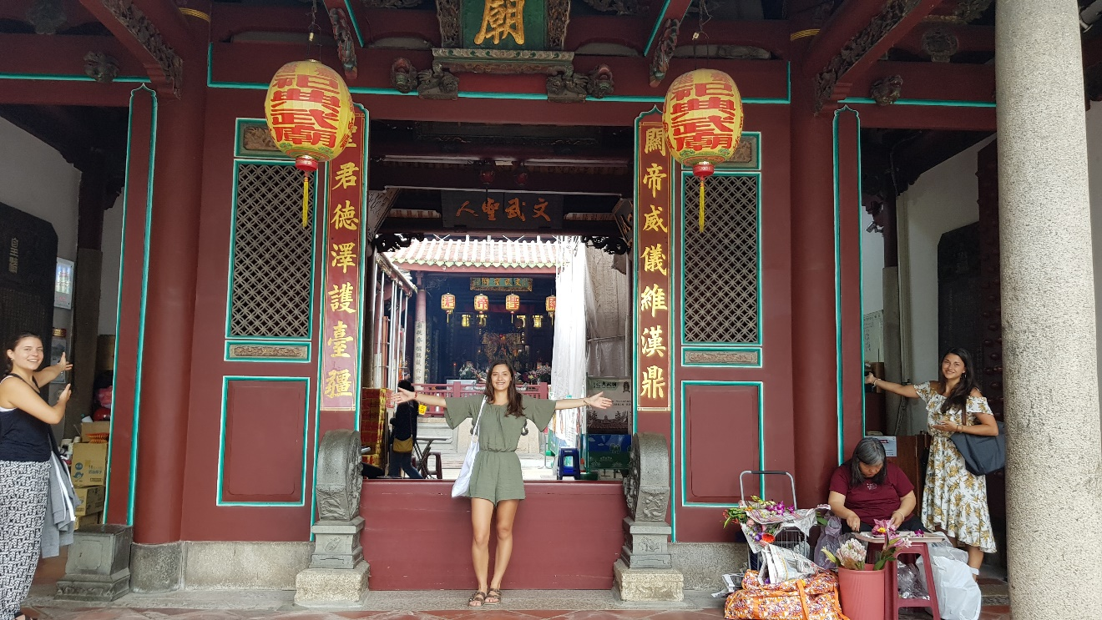
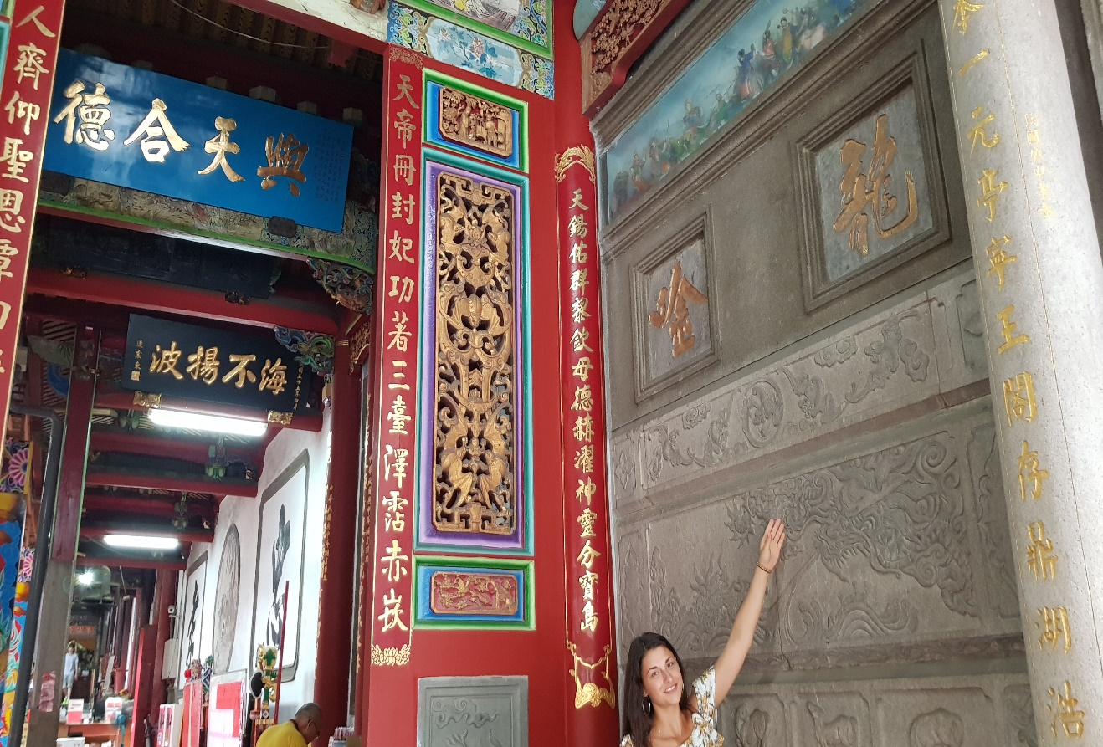
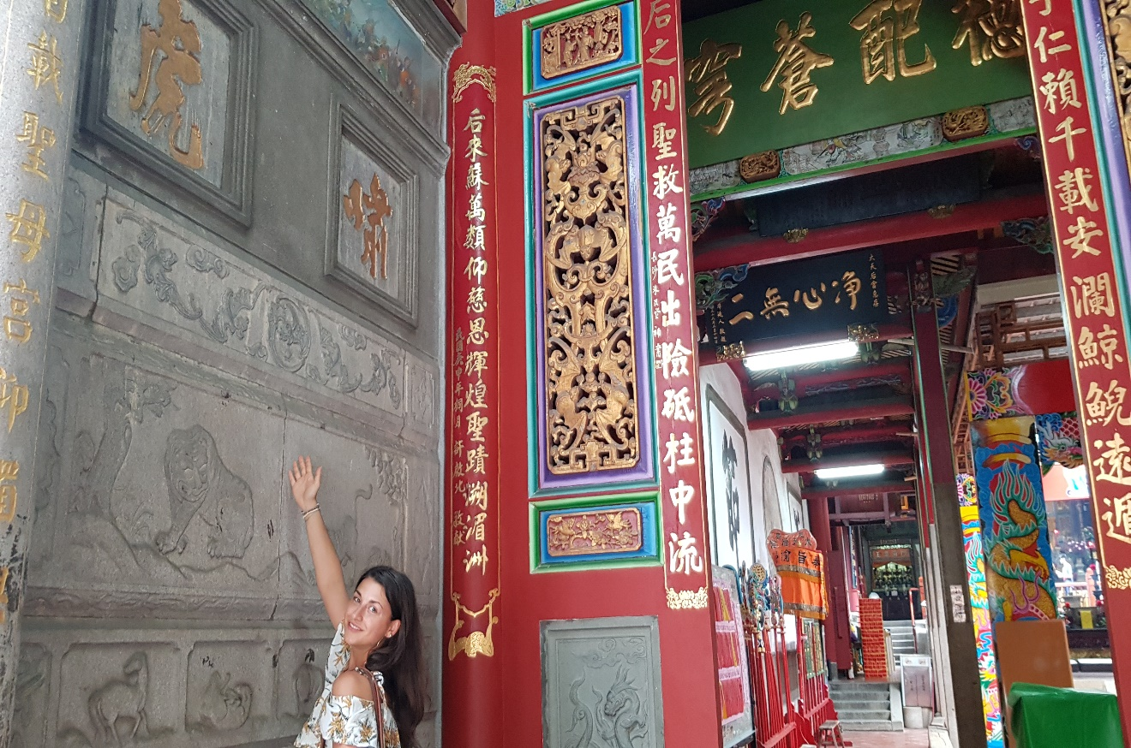
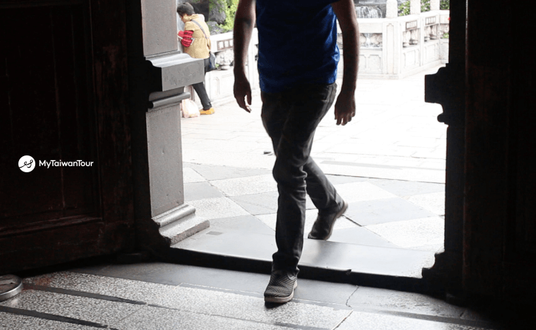

Door 1 Most Taiwan temples have three front doors. One should always enter through the right door, move in a counterclockwise direction in the temple, and then exit out the left door. The middle door is usually reserved for the temple deities, so one should avoid it.
Door 2 and 3 The right door is called the dragon door, and the left door is called the tiger door. The dragon is the symbol of the Imperial Family(皇族). By entering through the right door (gods’ left), we rise in rank(地位). The left door is the god’s right, guarded by a tiger, a symbol of peril(危險). By leaving through the left door (god’s right), we are out of danger.
Door 4 You have to cross the threshold (門檻) instead of stepping on it because that's considered rude.

3. Symbols (象徵) in temples
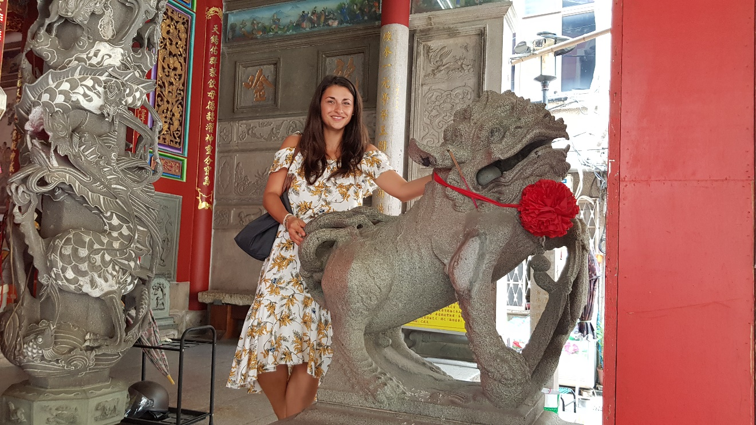
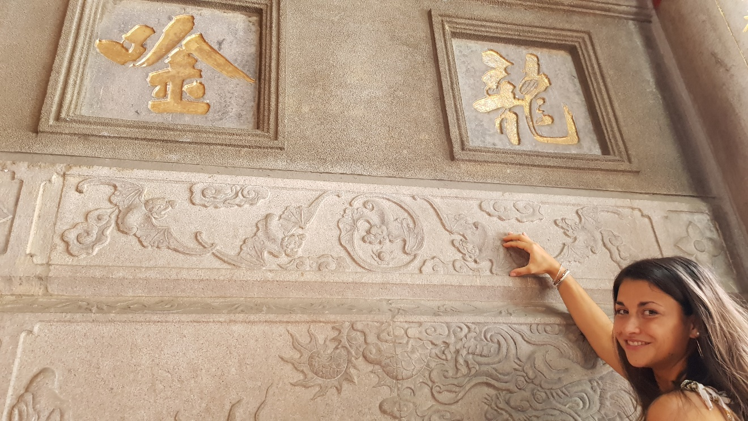
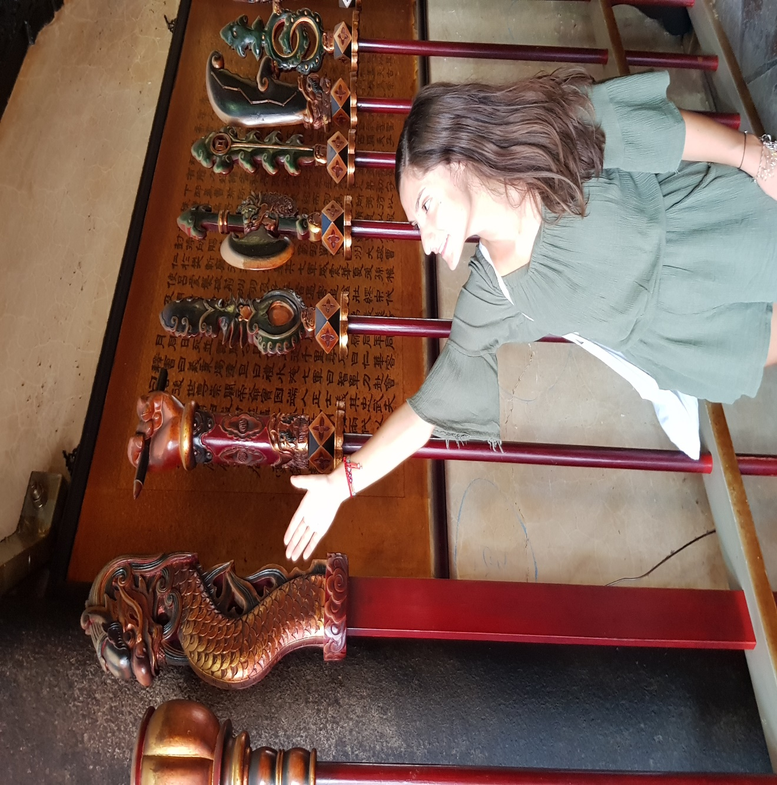
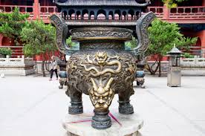

Symbol 1 In front of a temple, one can usually see dragon pillars (龍柱). In Chinese society, dragons symbolize power, heaven, and good fortune. Dragon pillars in front of the temple can serve as guardians of the temple.
There are also stone lions to guard the temple. Lion symbolizes safety and luck.
Symbol 2 Beside the right door of Grand Matzu temple, one can see five bats carved on the wall. Bats are pronounced the same as “blessing”(福). The five bats on the wall means “Five kinds of blessing come to the door of your house” (五福臨門) in Chinese saying.
Symbol 3 On the top of the weapon is one of the nine sons of the dragon, who is named Yai-tzu (睚眥). The dragon’s nine sons have different characters and different symbolic meanings and are used to decorate different things in the temple. Yai-tzu is very violent and likes to fight, so he is used to decorate weapons.

Symbol 3 On the surface of the incense burner (香爐) is another son of the dragon called Suan Ni. He like smoke and fire, so he is used to decorate the incense burner.

4. Incense (香)
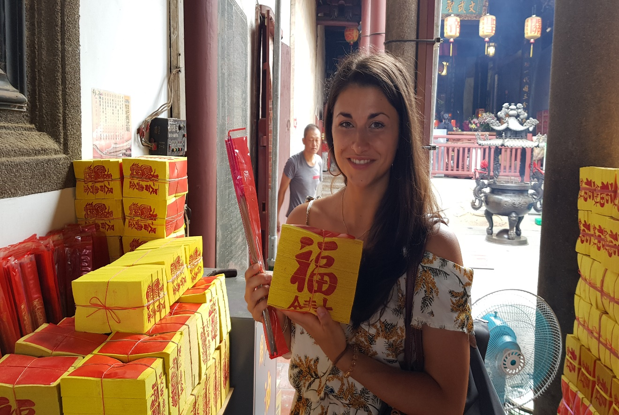
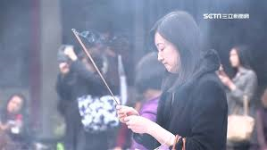
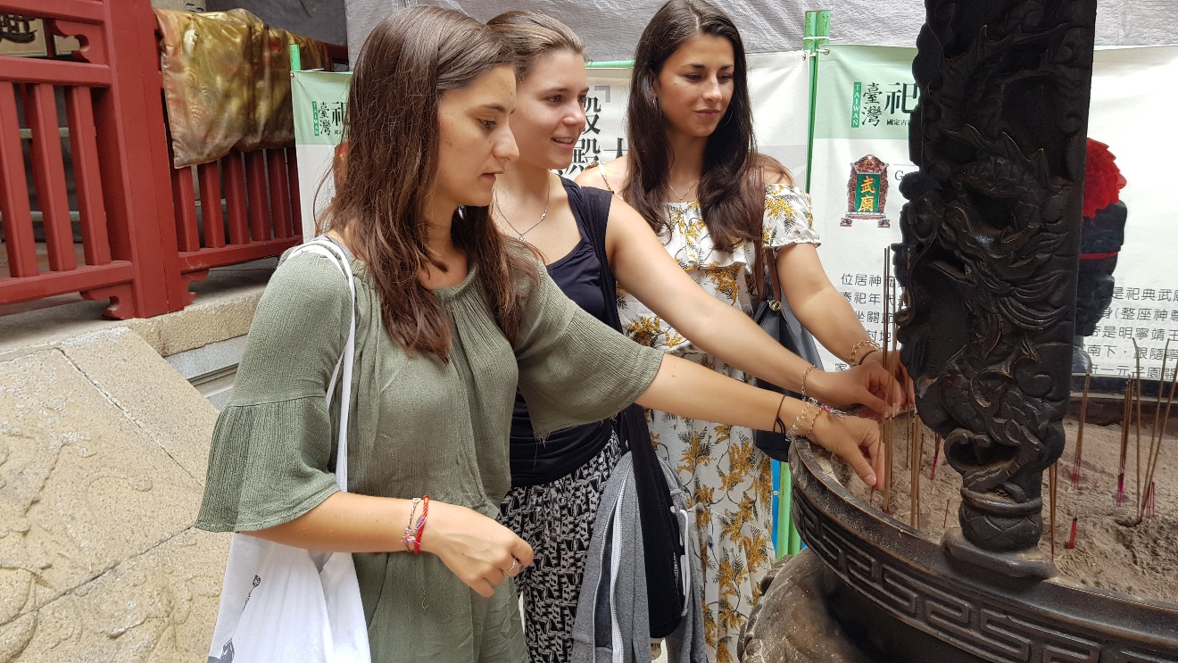

Incense 1 These two things, the incense sticks (香)and spirit money(紙錢), are usually available right in front of the temple or at its entrance. Before praying, people need to buy incense sticks and spirit money because Taiwanese believe that incense sticks can help people communicate with gods and after praying they burn the spirit money because they believe that gods or ghosts can use this kind of money.
Incense 2 The smoke of the incense is believed to gain the attention of gods, thus allowing one's prayers to be heard, and it has the cleansing(洗淨) powers.
Incense 3 You have to use your left hand rather than your right hand to put the incense sticks into the incense burner (香爐)because your left hand is closer to where your heart is and that symbolizes being more faithful and more genuine.

5. Divination blocks (擲筊)
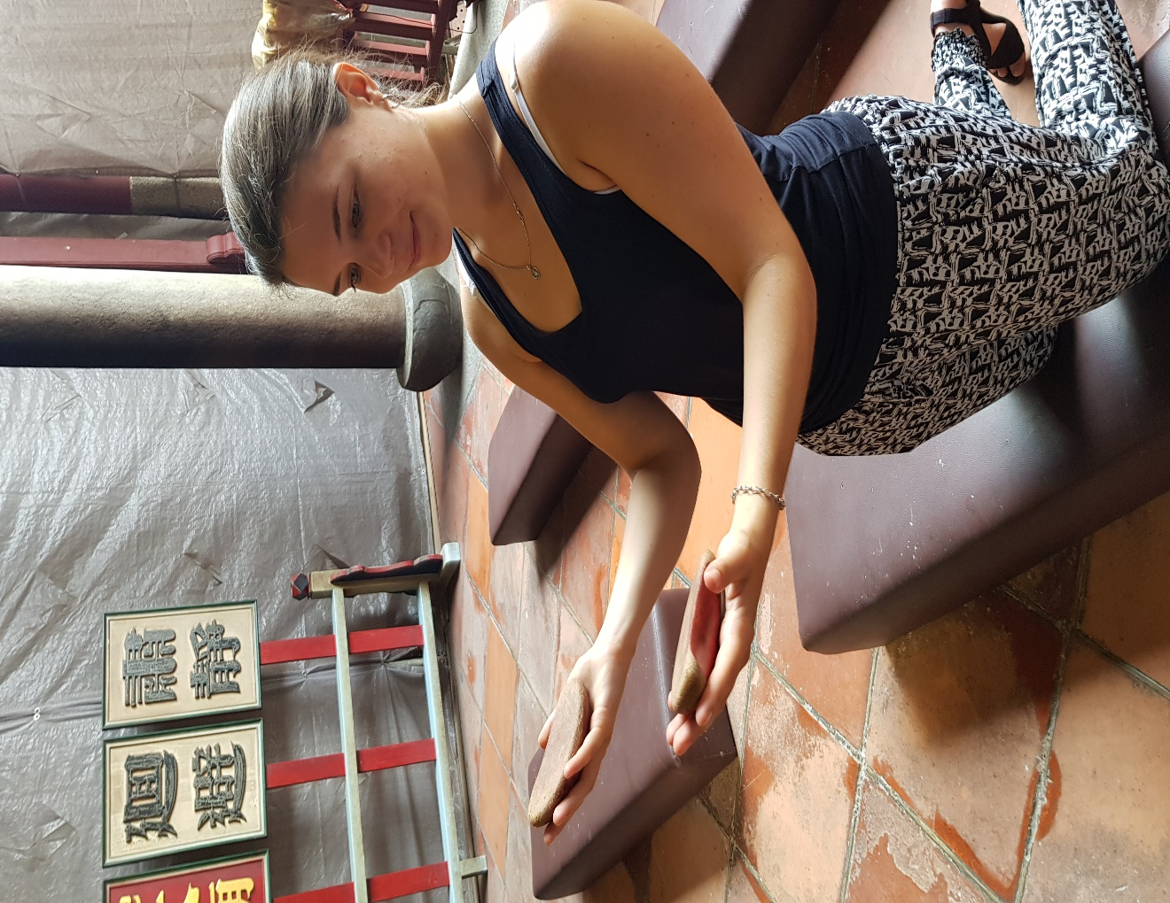
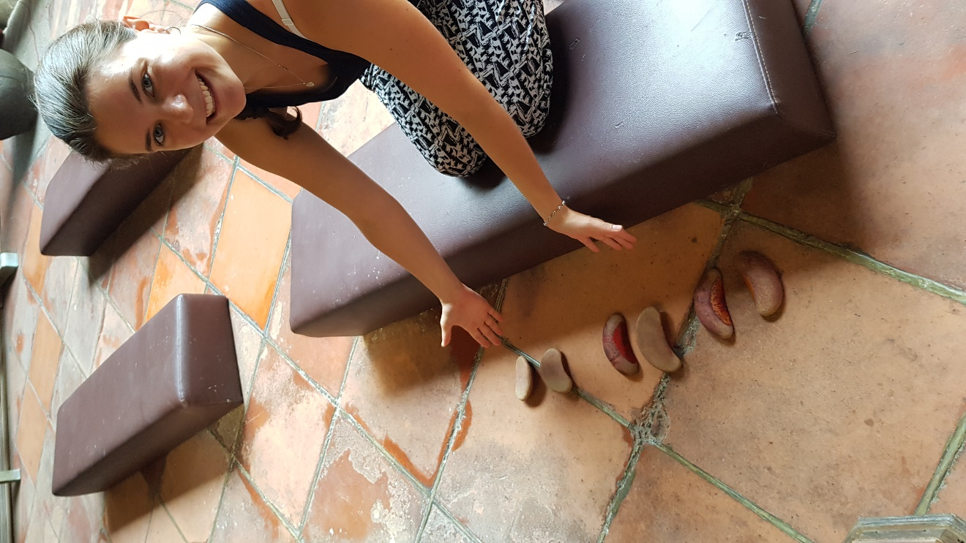
Divination blocks 1. Most of the temples have curved wooden or plastic blocks that people throw onto the ground to ask the opinions of the gods to help people make important decisions.
The blocks have one flat side and one curved side. They are used in pairs and thrown onto the ground in order to indicate the wills of the gods. Generally painted red, the curved side represents the yin (陰) while the flat side represents the yang (陽). To find the answer to a question, the person praying must pray to the deity of the temple and provide the deity with very specific details, such as their names, addresses, and date and time of birth.
Before you ask the god the question, you have to stand in front of the god and introduce yourself (including your name, address and age) and then ask a question that requires a "yes" or "no" response. For example, you can ask the god whether it is good to marry someone or whether it is good change your job.
Divination blocks 2. One with the flat side up and the other with the rounded side up is "Yes." Both with the rounded side up means "No." And two flat sides up indicates the answer is uncertain or the question wasn't clear enough.

6. Fortune sticks (籤)
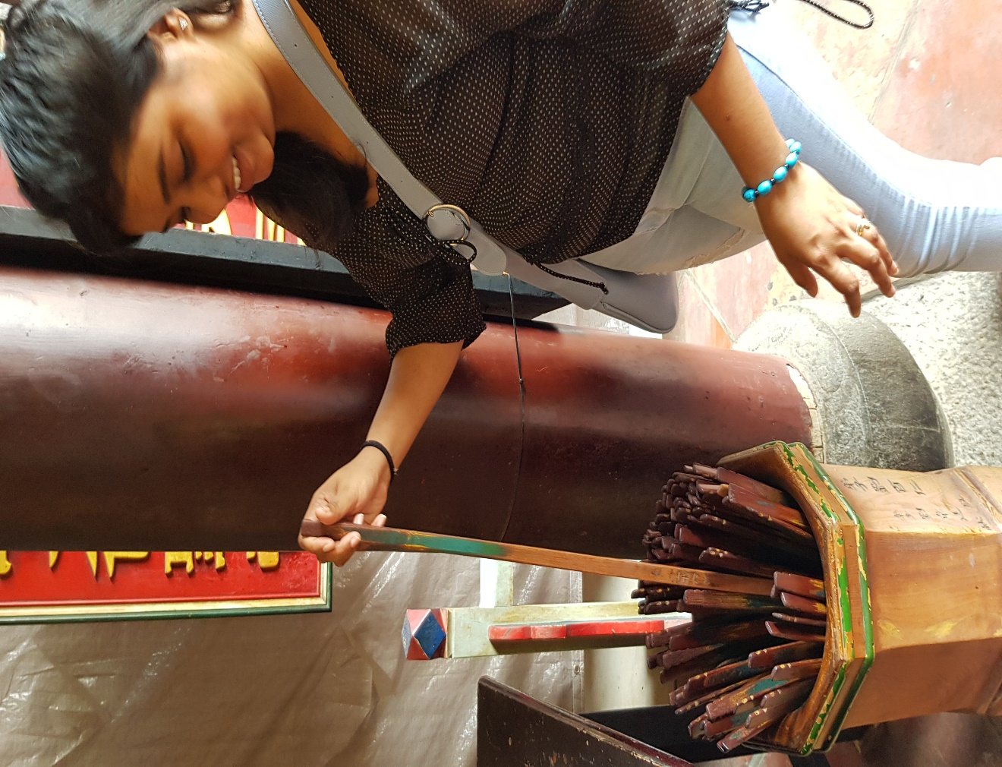
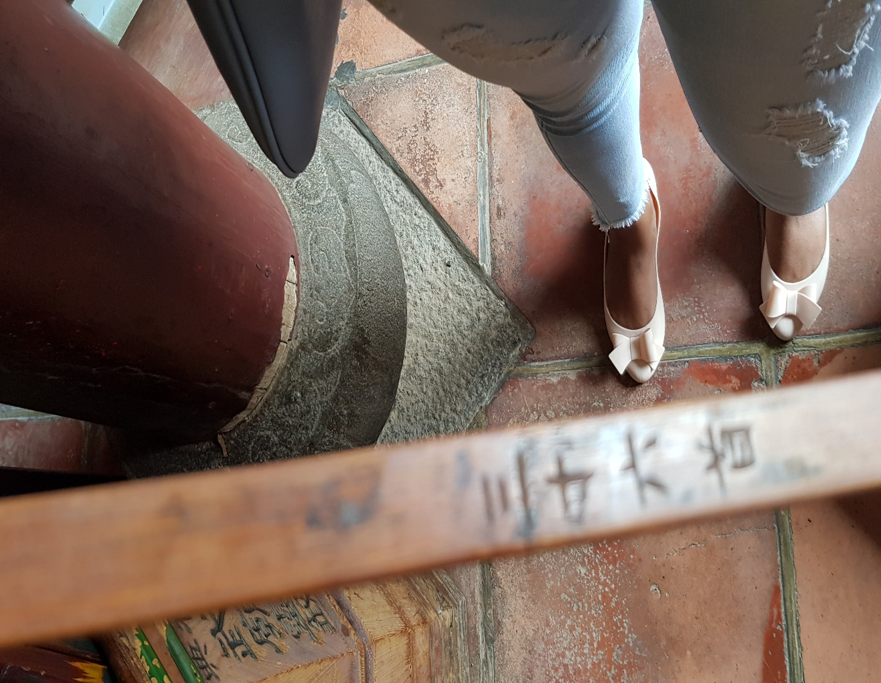
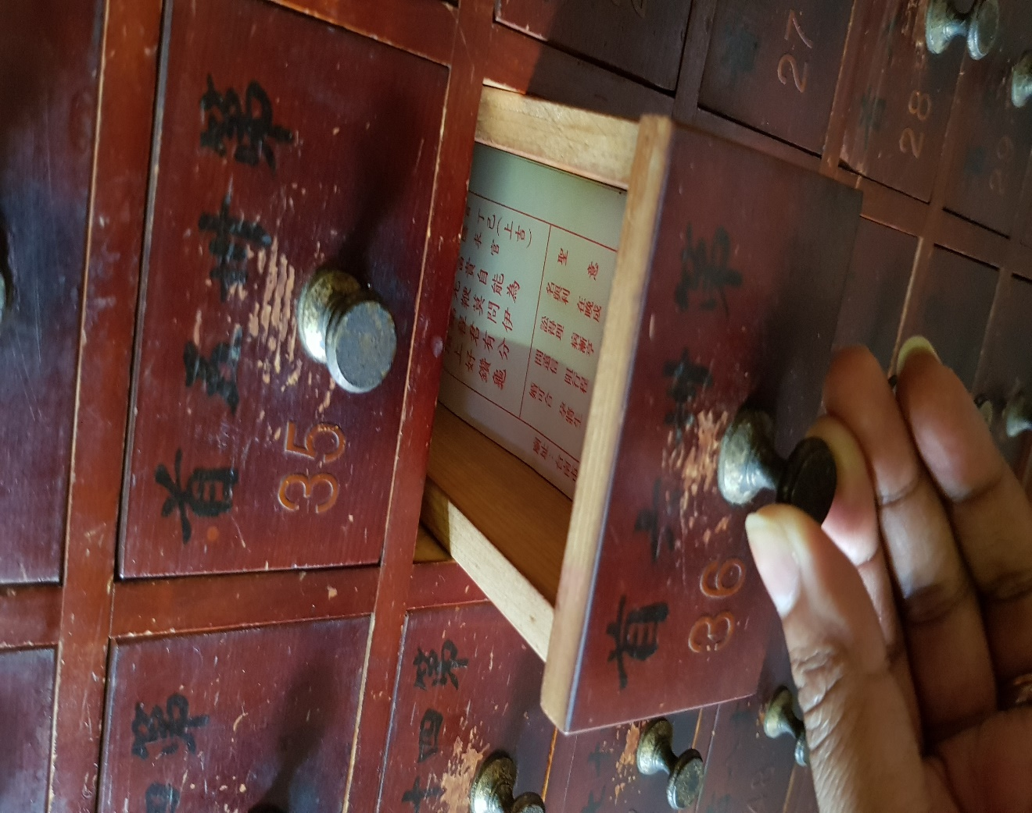
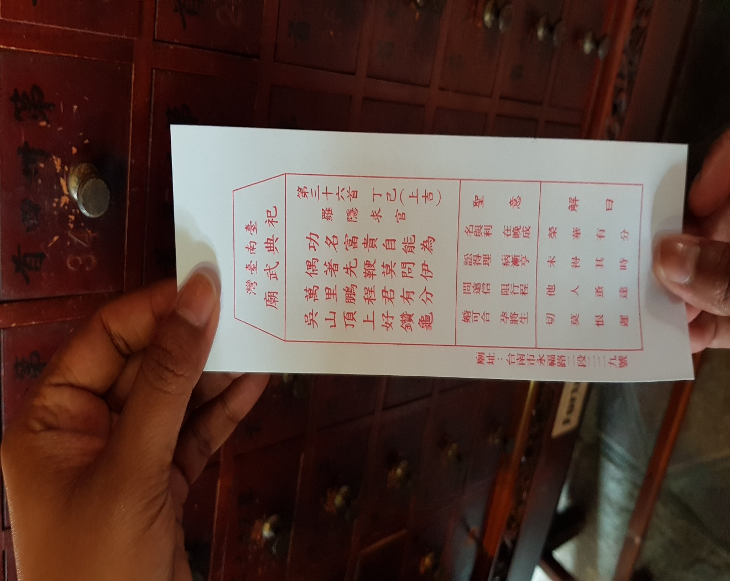
Fortune sticks 1 are long, flat sticks to provide believers with answers from the gods. The fortune sticks sit in a bucked called 籤筒. There are usually a total of 100 sticks in the bucket. After praying, the believer mixes the sticks and then picks up one of them.
Fortune sticks 2 On each stick is a unique number which corresponds to one of the hundred written oracles with an answer on it.
Fortune sticks 3 The written oracles are written on pieces of papers put in drawers in a cabinet.
Fortune sticks 4 You can open the drawer with the number and take out the paper with the oracle.

7. Gods
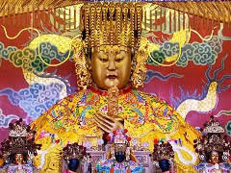
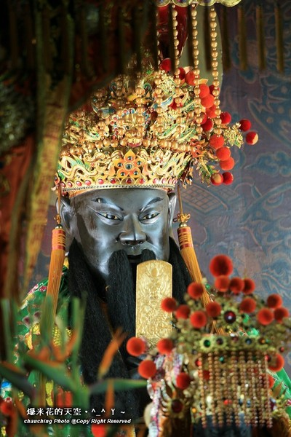

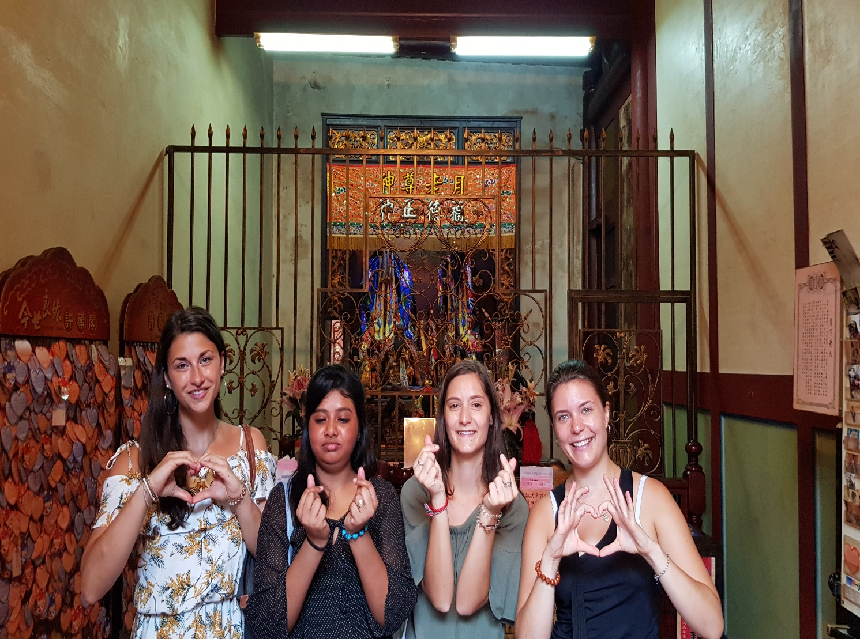

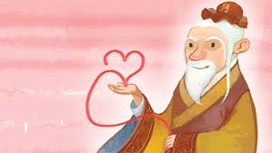

You can make different prayers to different gods depending on their specialties and your needs.

Matsu Matsu is the Goddess of the Sea and is the most worshipped god in the Taiwanese society. There are about 870 temples dedicated to Masuu in Taiwan. Matsu's birthday is in the third month of the Chinese lunar calendar, and at that time temples all over the island hold birthday activities and there is a Mazu pilgrimage(迎媽祖).
Guan Gong was a historical person, a general, who lived in China 1800 years ago (CE 220-CE 280). Because Guan Gon is a very brave and righteous person and is good at managing wealth, so after his death, people worshipped Guan Gong as the martial saint(武聖), guarding people against evil spirits, and as a patron saint of commerce(商業守護神).
Yue Lao Old Man under the Moon (月下老人)is a god of marriage and love, worshipped especially by unmarried men and women. He is called “Old Man under the Moon” because when he was seen sitting under the moon at night. Believers believe that if they pray to the god and get a red thread (紅線), which can connect unmarried men and women, they will quickly find a mate.

8. Others
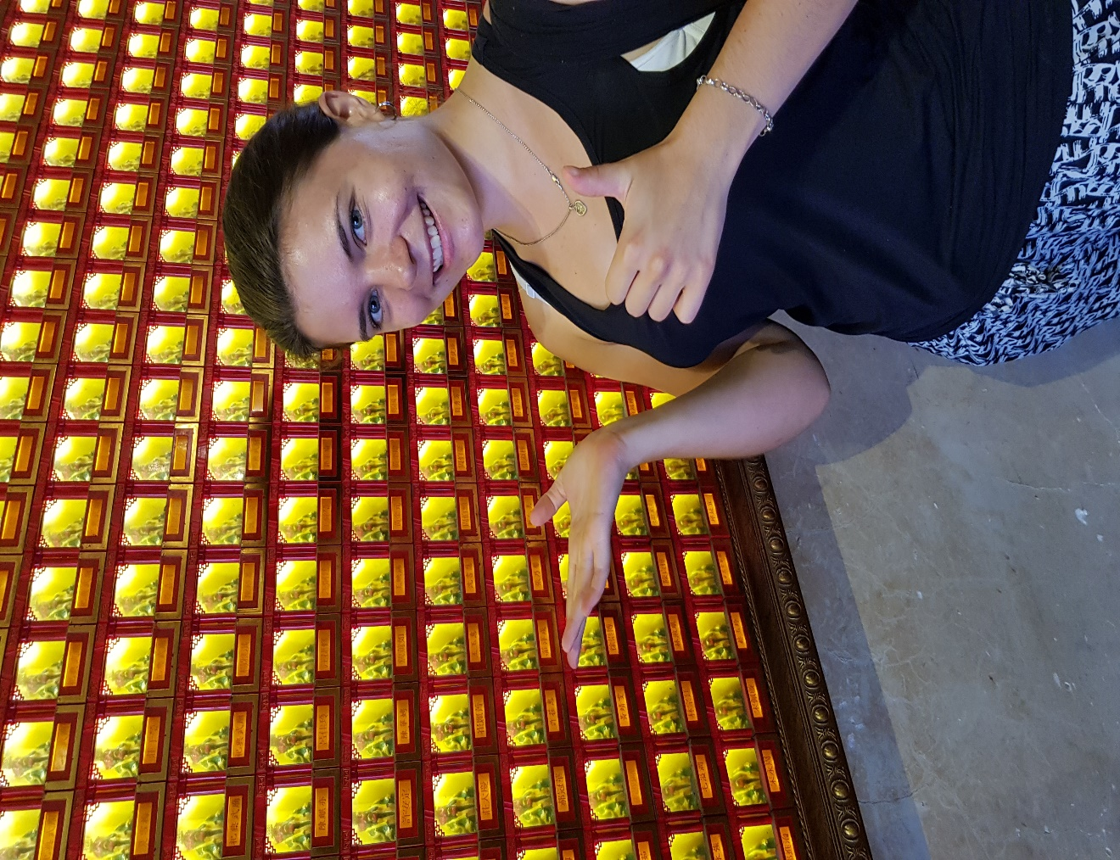
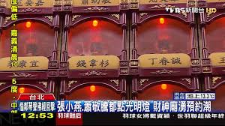

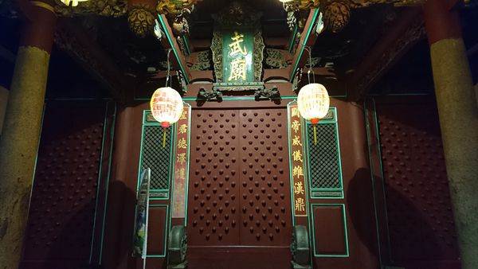
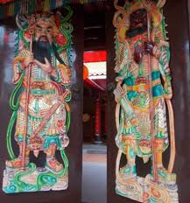
Others 1 In the temple, you can always see a wall filled with lamps in cells (格)and below each cell there is the name of a person which is the sponsor of the lamp. The sponsor of the lamp can gain blessings and peace for their family in the upcoming year.
Others 2 In all temples, there are usually pictures of guarding gods on the front doors. But on the front doors of Tainan Wu Temple (祀典武廟), there are no guarding gods. The doors of the temple are decorated with the door nails (門釘) instead, which can only be applied to temples where official rites(祀典) are held.

