1.Temples
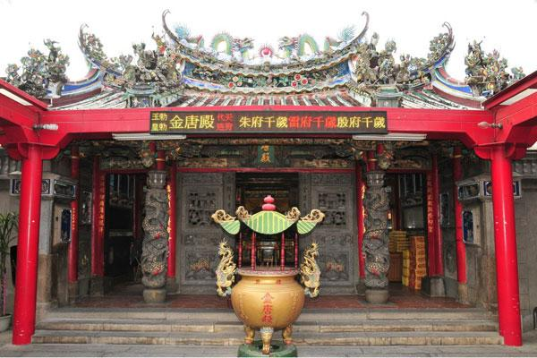

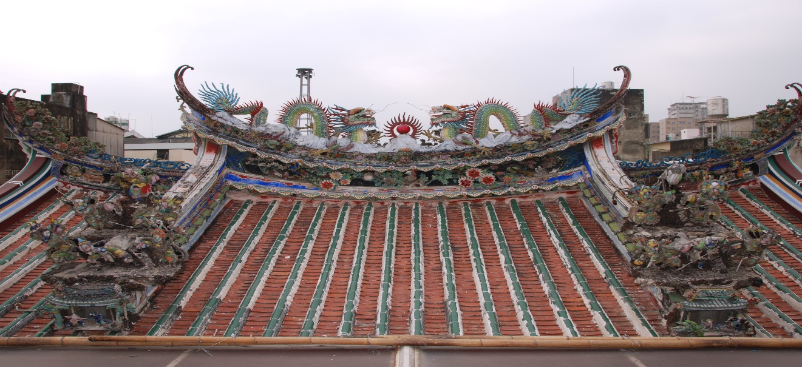
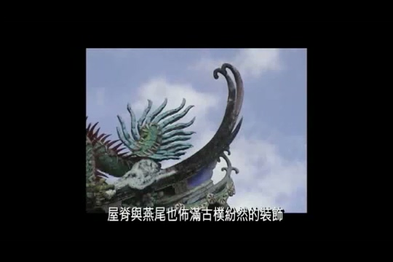

Jintang Temple.
a) Temples in Taiwan follow the basic principles of southern Chinese architecture. Temples generally have one or more halls. The middle part of the roof’s ridgeline(屋脊線) is like a saddle (馬鞍)but the end parts will curve upwards and look like the tail of a swallow. This is known as a swallowtail roof, and is a distinctive feature of southern Chinese temples.
b) The ridgeline is always decorated with dragons. In China, dragons have long symbolized power, heaven, and good fortune. People usually decorate roofs and gates of temples with dragons.

2. Temple doors
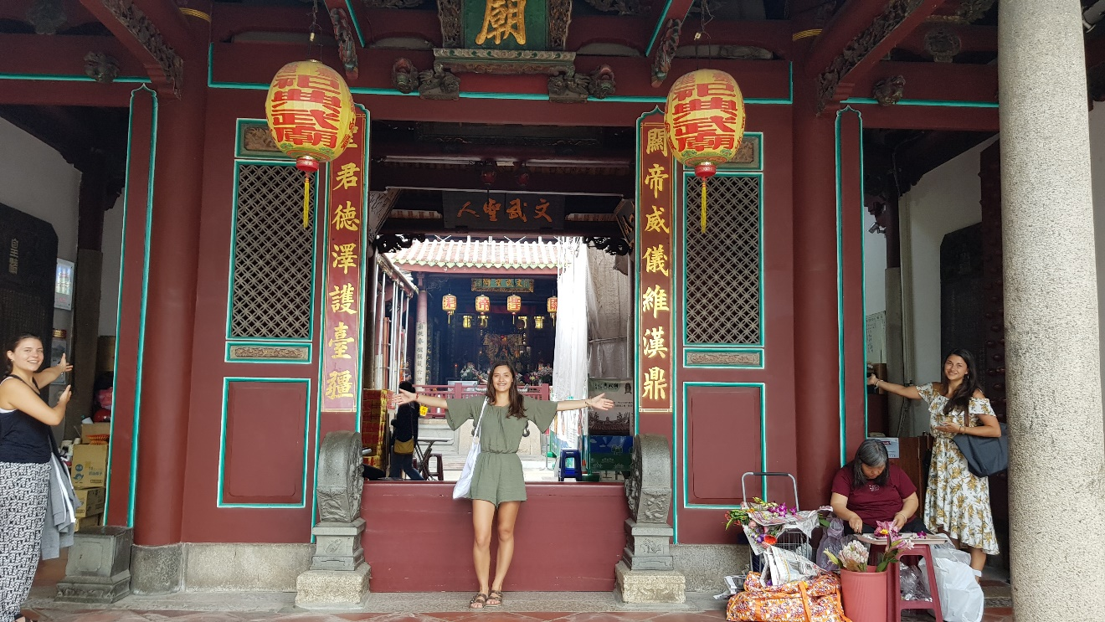

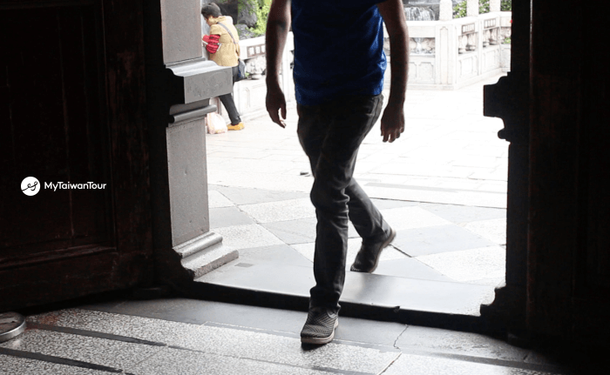

Door 1 Most Taiwan temples have three front doors. One should always enter through the right door, move in a counterclockwise direction in the temple, and then exit out the left door. The middle door is usually reserved for the temple deities, so one should avoid it.
Door 2 You have to cross the threshold (門檻) instead of stepping on it because that's considered rude.

3. Symbols (象徵) in temples
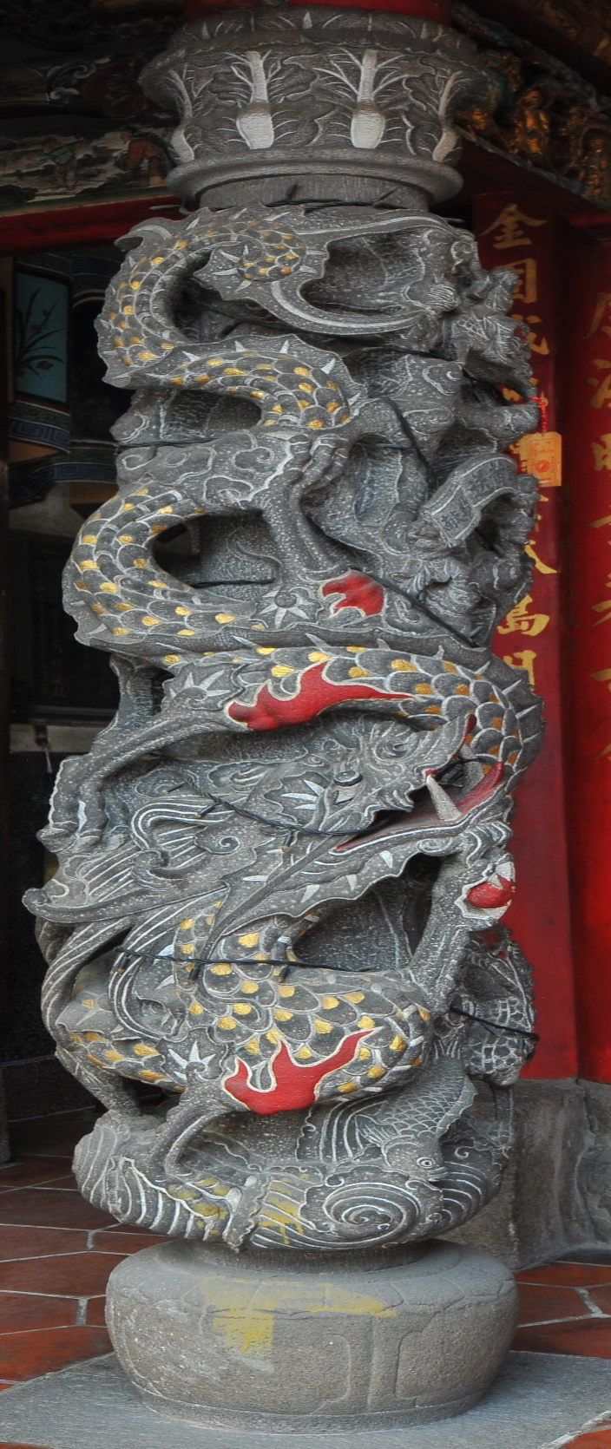

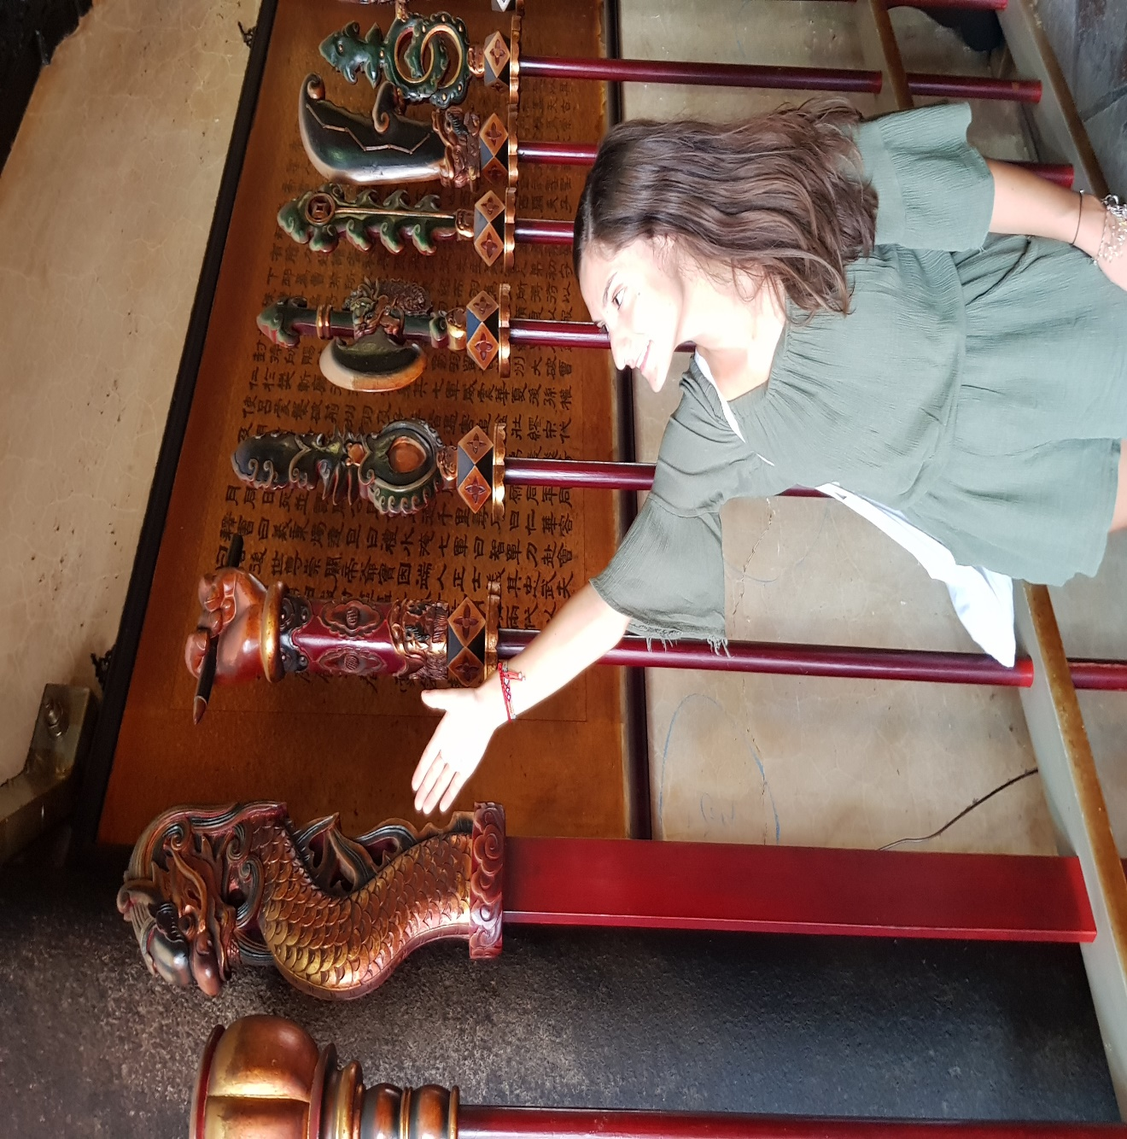
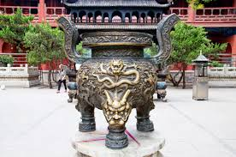
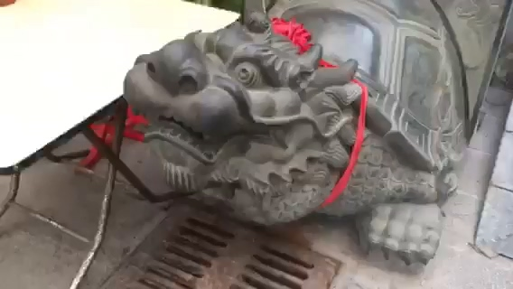

Symbol 1 In front of a temple, one can usually see dragon pillars (龍柱). In Chinese society, dragons symbolize power, heaven, and good fortune. Dragon pillars in front of the temple can serve as guardians of the temple.
There are also stone lions to guard the temple. Lion symbolizes safety and luck.
Symbol 2 On the top of the weapon is one of the nine sons of the dragon, who is named Yai-tzu (睚眥). The dragon’s nine sons have different characters and different symbolic meanings and are used to decorate different things in the temple. Yai-tzu is very violent and likes to fight, so he is used to decorate weapons.

Symbol 3 On the surface of the incense burner (香爐) is another son of the dragon called Suan Ni. He like smoke and fire, so he is used to decorate the incense burner.

Symbol 4 The dragon’s eldest son appeared as a tortoise, a creature capable of bearing very heavy stone steles. Tortoise statues were erected in ancient temples and courtyards, as people believed that to touch them could bring good luck.

4. Incense (香) and Joss Paper (紙錢)
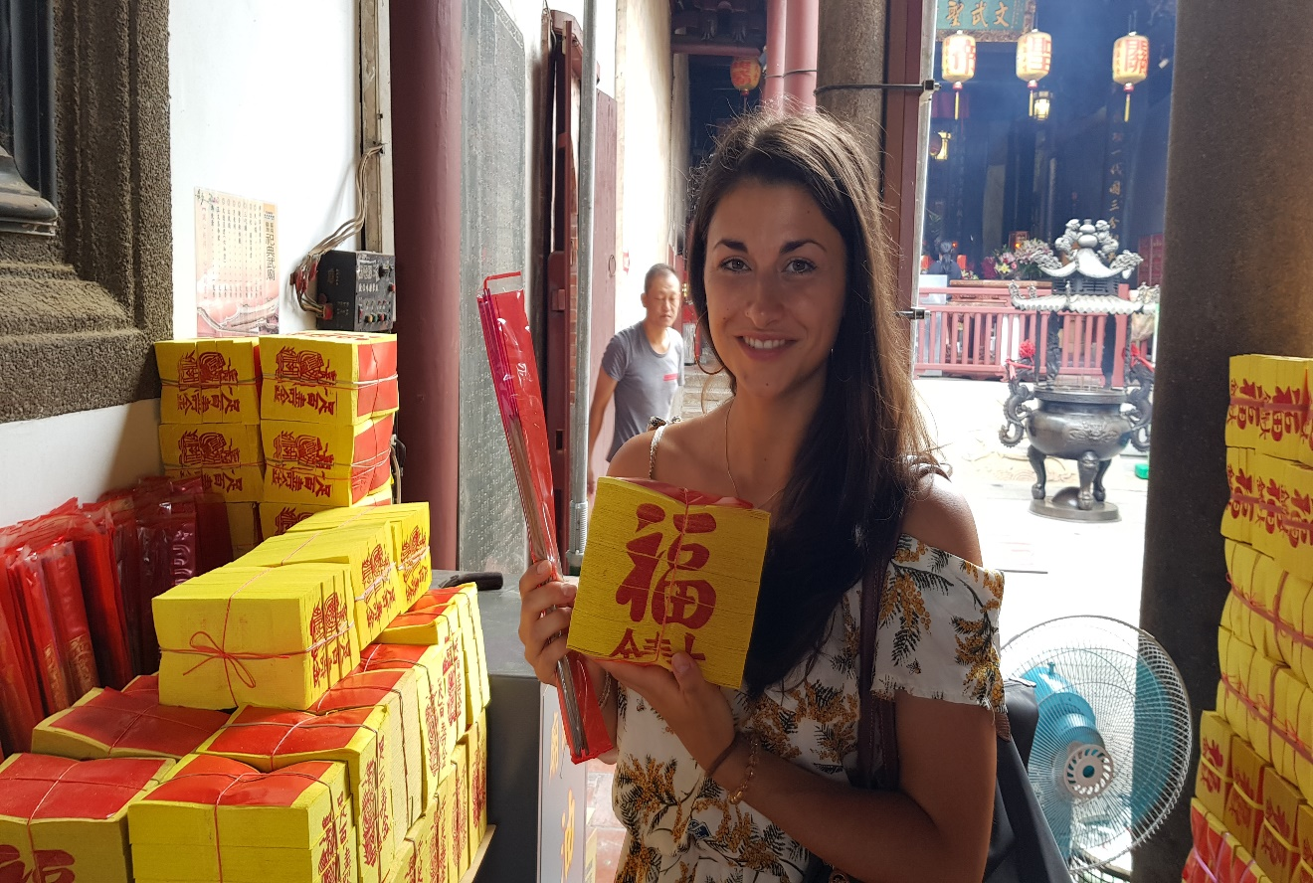
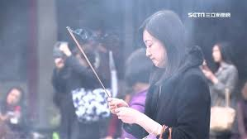
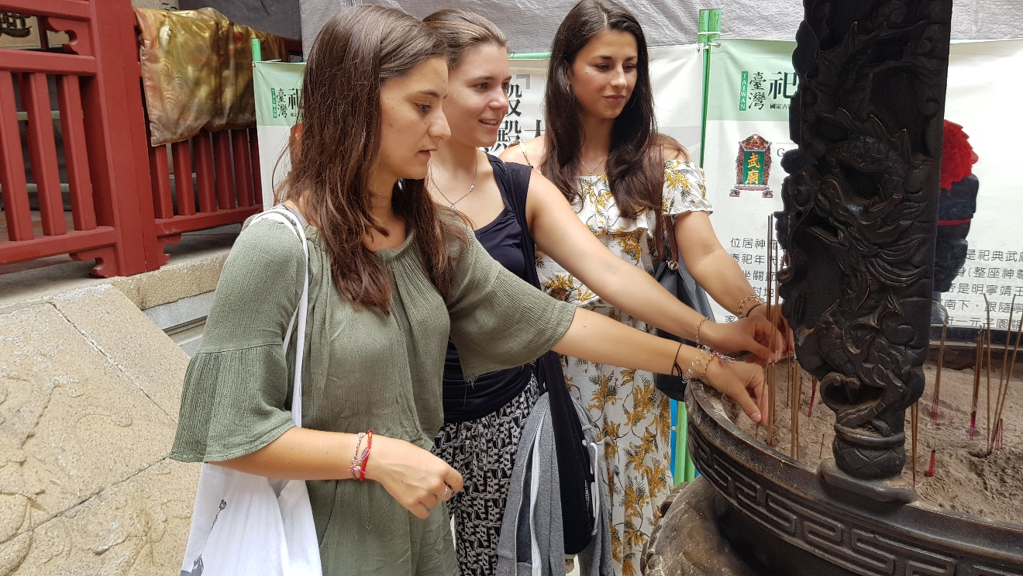

Incense 1 These two things, the incense sticks (香)and spirit money(紙錢), are usually available right in front of the temple or at its entrance. Before praying, people need to buy incense sticks and spirit money because Taiwanese believe that incense sticks can help people communicate with gods and after praying they burn the spirit money because they believe that gods or ghosts can use this kind of money.
Incense 2 The smoke of the incense is believed to gain the attention of gods, thus allowing one's prayers to be heard, and it has the cleansing(洗淨) powers.
Incense 3 You have to use your left hand rather than your right hand to put the incense sticks into the incense burner (香爐)because your left hand is closer to where your heart is and that symbolizes being more faithful and more genuine. Joss paper, sometimes called “ghost money” or “spirit money,” is paper burned during religious rites to honor ancestors and venerate deities.
Joss paper Joss paper, sometimes called “ghost money” or “spirit money,” is paper burned during religious rites to honor ancestors and venerate deities. Those burned for ancestors are silver and those for deities are gold.

5. Divination blocks (擲筊)
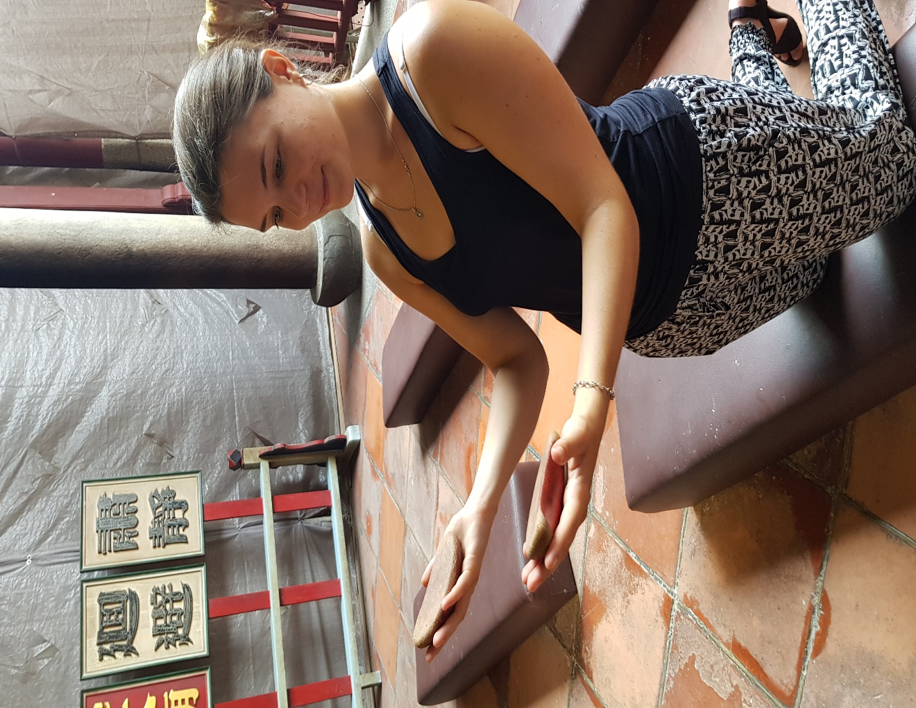
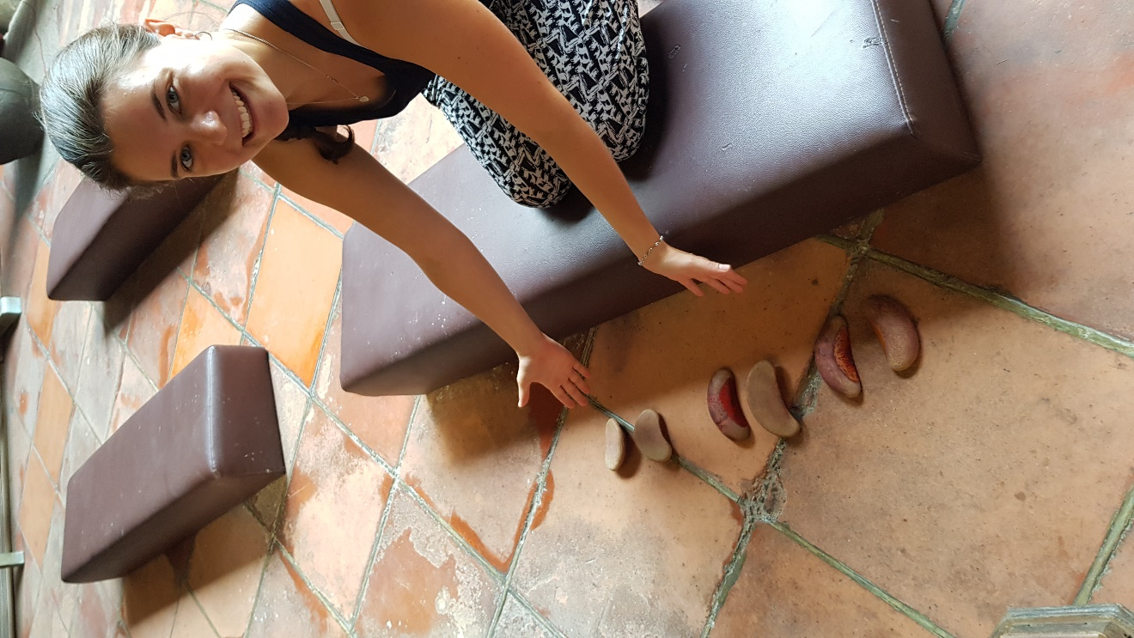
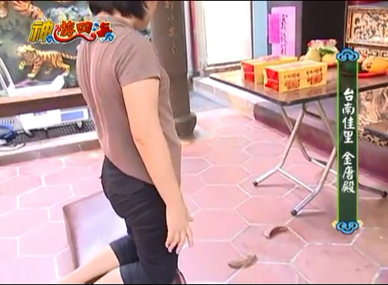

Divination blocks 1. Most of the temples have curved wooden or plastic blocks that people throw onto the ground to ask the opinions of the gods to help people make important decisions.
The blocks have one flat side and one curved side. They are used in pairs and thrown onto the ground in order to indicate the wills of the gods. Generally painted red, the curved side represents the yin (陰) while the flat side represents the yang (陽). To find the answer to a question, the person praying must pray to the deity of the temple and provide the deity with very specific details, such as their names, addresses, and date and time of birth.
Before you ask the god the question, you have to stand in front of the god and introduce yourself (including your name, address and age) and then ask a question that requires a "yes" or "no" response. For example, you can ask the god whether it is good to marry someone or whether it is good change your job.
Divination blocks 2. One with the flat side up and the other with the rounded side up is "Yes." Both with the rounded side up means "No." And two flat sides up indicates the answer is uncertain or the question wasn't clear enough.

6. Fortune sticks (籤)
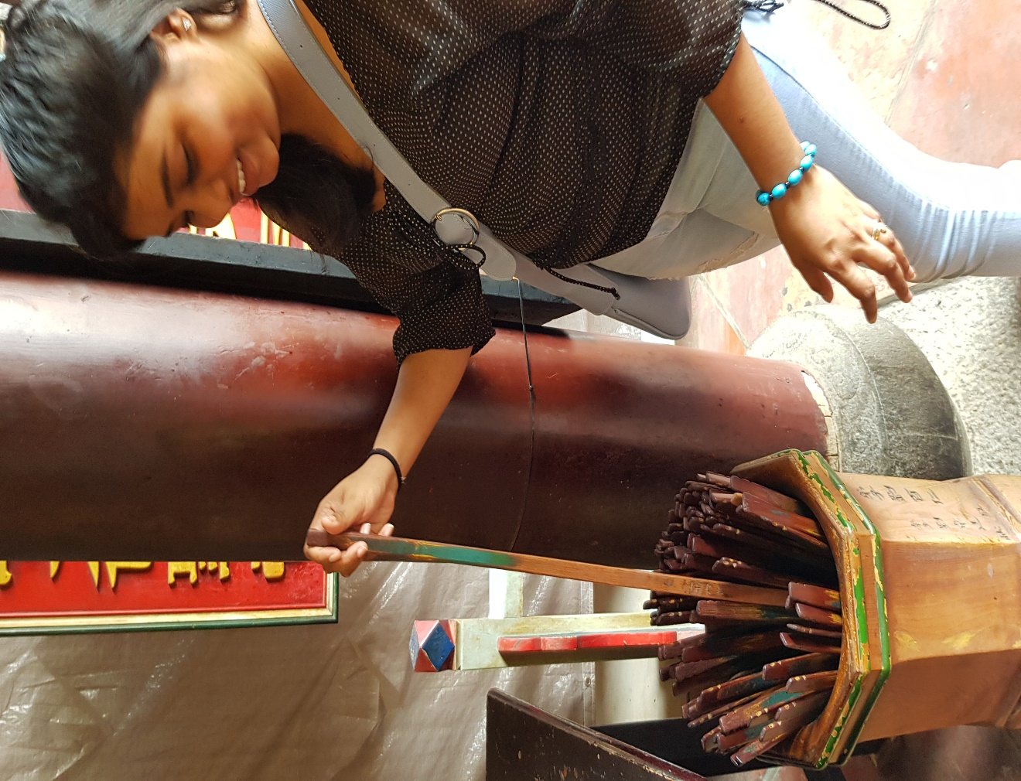
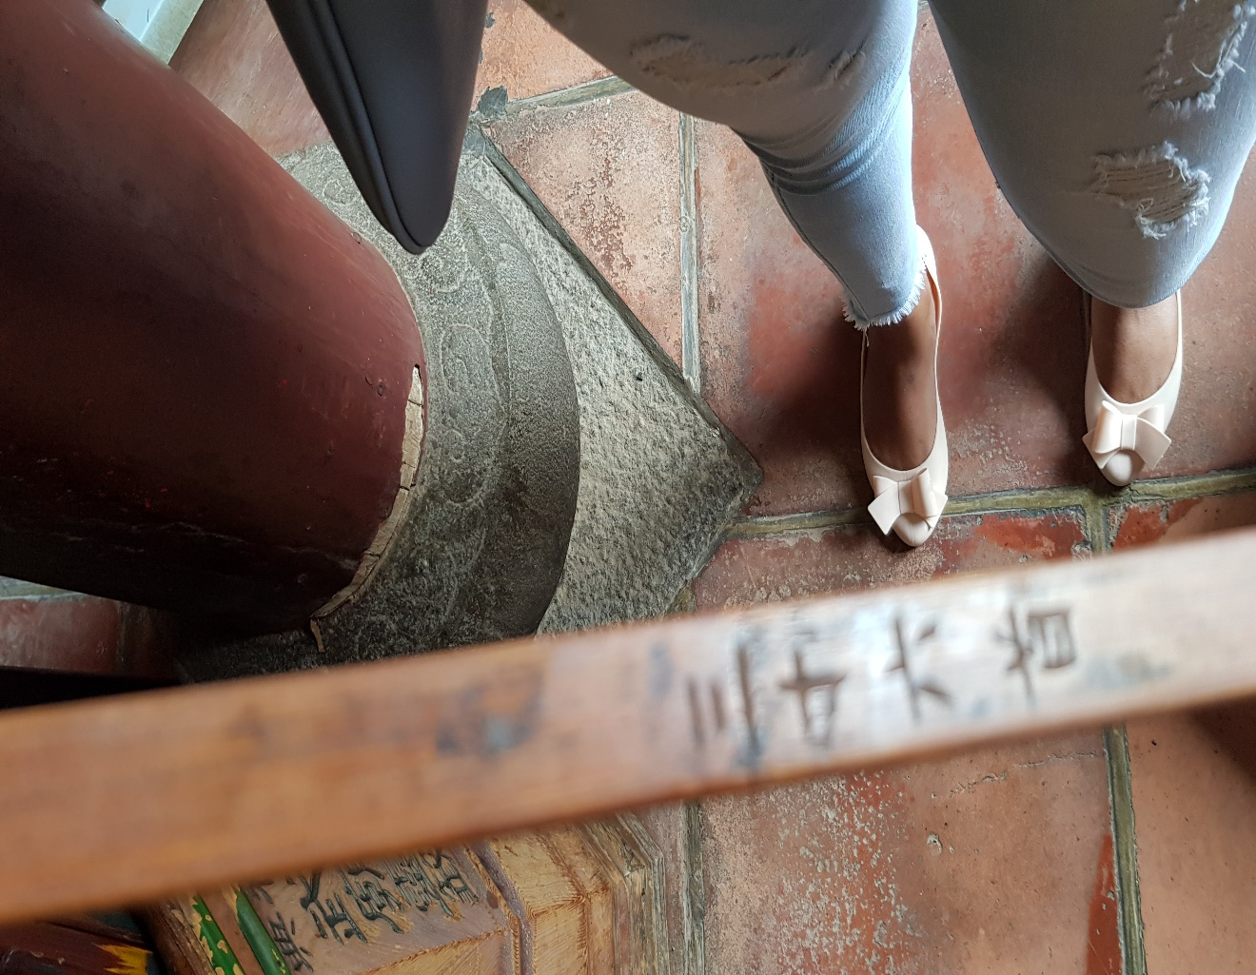
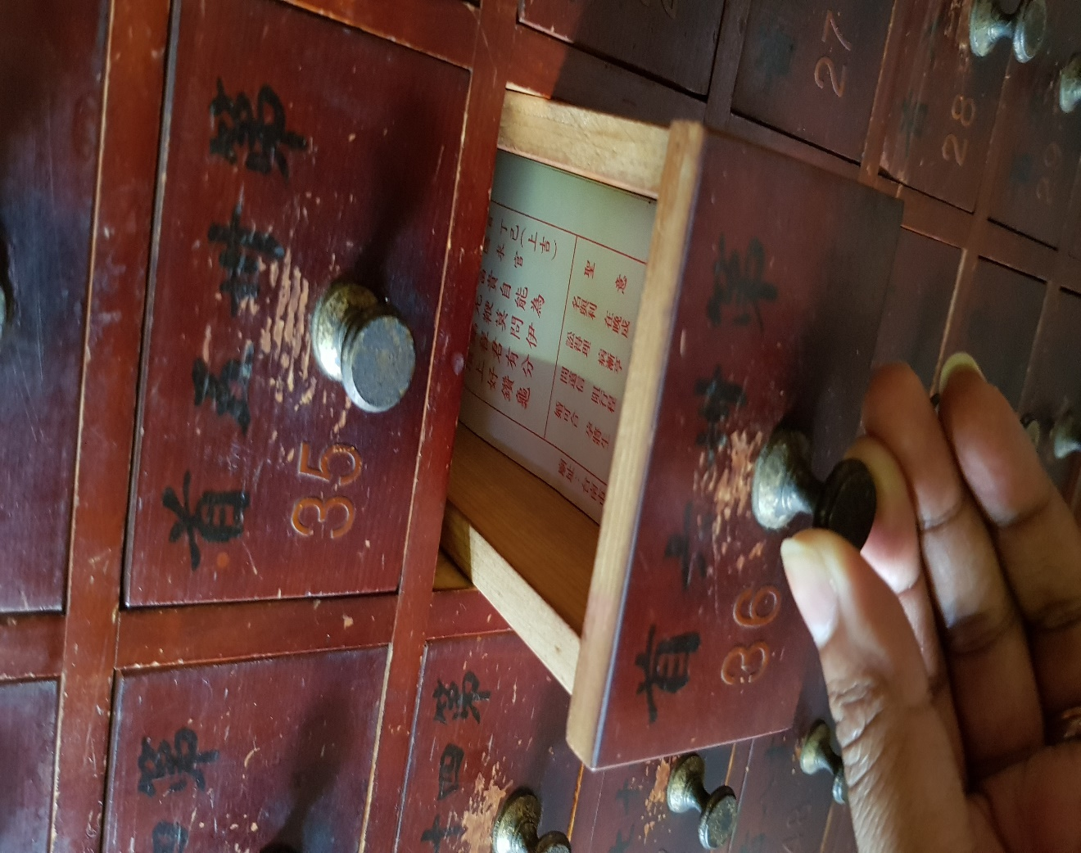
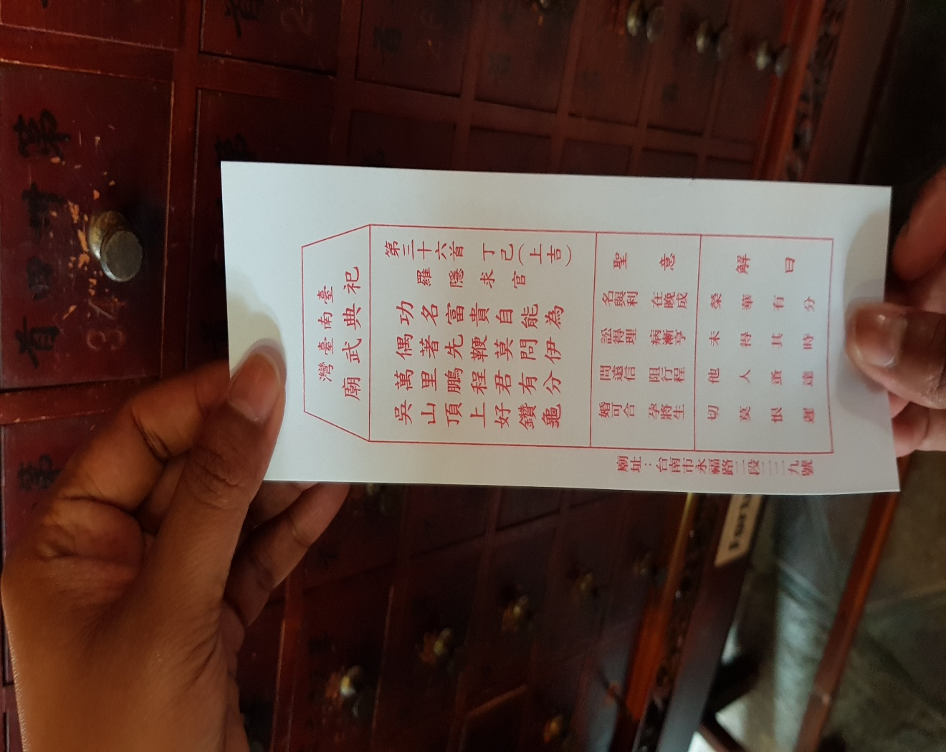
Fortune sticks 1 are long, flat sticks to provide believers with answers from the gods. The fortune sticks sit in a bucked called 籤筒. There are usually a total of 100 sticks in the bucket. After praying, the believer mixes the sticks and then picks up one of them.
Fortune sticks 2 On each stick is a unique number which corresponds to one of the hundred written oracles with an answer on it.
Fortune sticks 3 The written oracles are written on pieces of papers put in drawers in a cabinet.
Fortune sticks 4 You can open the drawer with the number and take out the paper with the oracle.

7. Gods
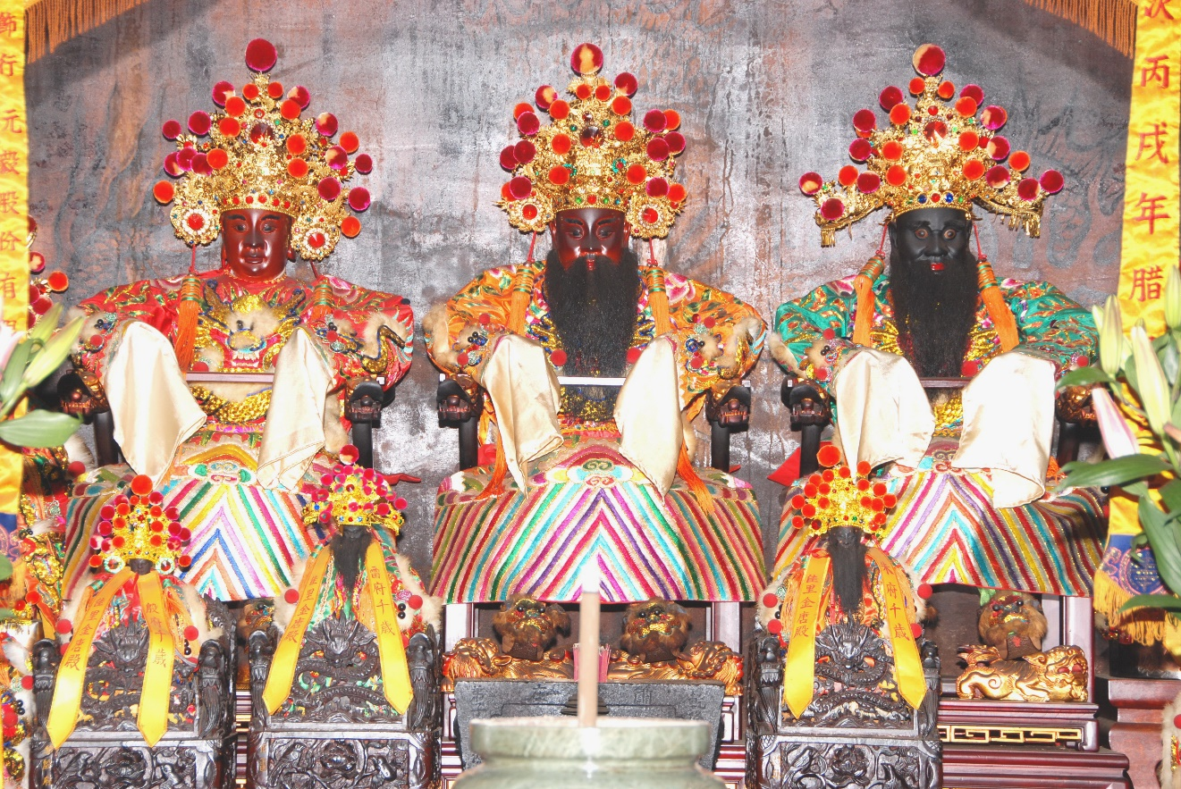

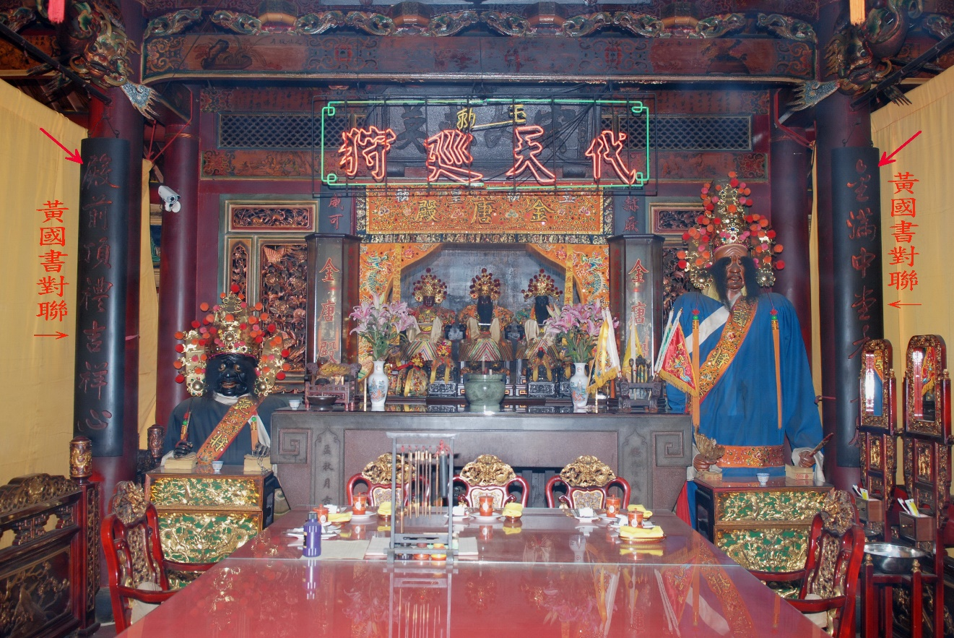
Gods 1—Wangye王爺Wang Ye belief began with the legend of five kind-hearted scholars who committed suicide in a well with epidemics 瘟病in the well water, trying to stop the villagers from drinking water and to stop the spreading of the epidemics. People later honored and prayed to those scholars who sacrificed their own lives for the public. As time passed by, these people are honored as Wang Ye and gradually became disease-dispelling gods and bringers of good fortune.

Gods 2 ---Qi Ye and Ba Ye (七爺八爺) The 7th Lord and 8th Lord, who bring the souls of the dead before the judge of the underworld, according to Chinese folk religion.

8. Decocrations
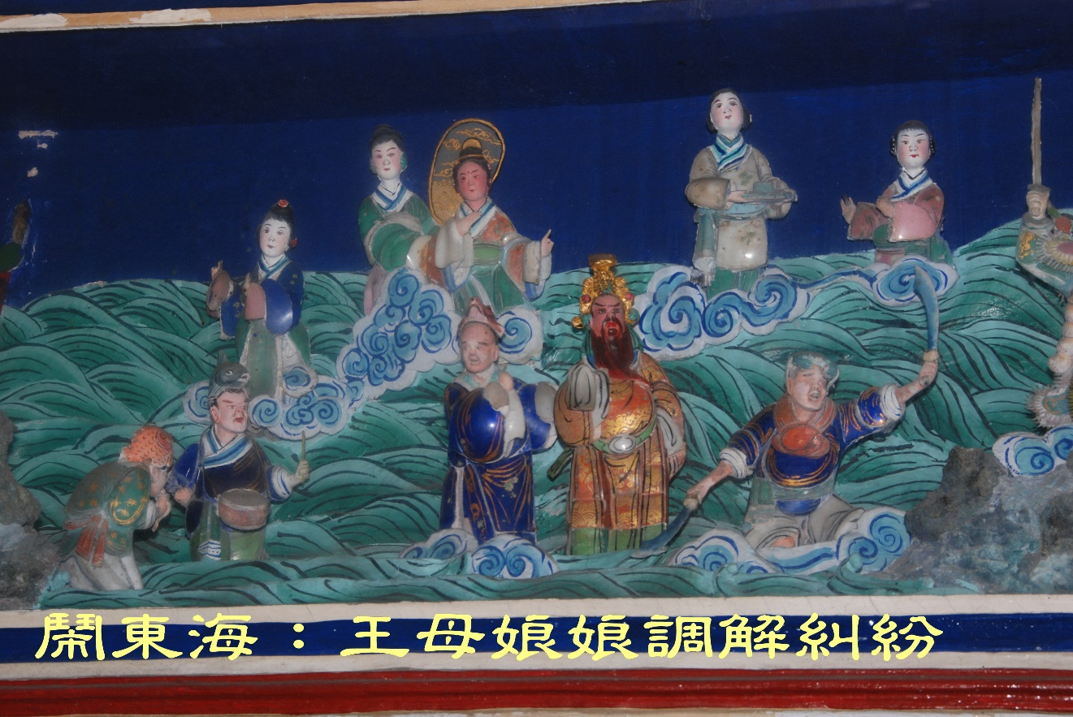

Legends, folk stories, and historical characters are portrayed on temples roofs and lintels like scenes of a story book. In addition to the sages, generals and characters from Chinese mythology typically featured in temple decorations
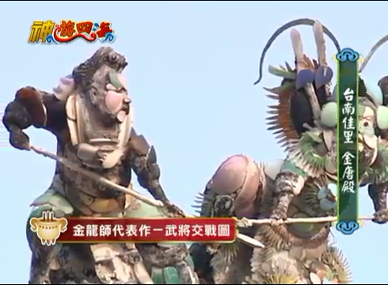

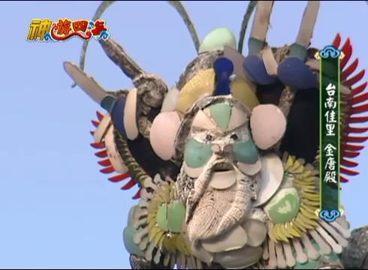
何金龍He Jin-long
The famous craftsman He Jin-long was invited to make fragmented ceramic (瓷器)works.

Chien-nien剪粘 it was only during the Ching dynasty (1644-1911) that craftsmen began decorating temple roofs with complex arrangements of the ceramic (瓷器) human and animal figures called chien nien. The term literally means "cut and glue" . Chien nien art provides vivid figures (人物)in history, literature, myths, and religion of China. The figures were constructed from flawed or broken ceramic bowls(破瓷碗).

